2.2 Requirements Specification

The requirement specification comprises high-level descriptions for the software's functional and non-functional specifications, as well as use cases that show how a user would interact with the system when it is completed. It is one of the most important documents in software development is the requirement specification. It explains how a software system should be produced and gives everyone concerned a project plan.

2.2.1 Problem Domain Description

The problems and constraints that clerical management systems impose on stakeholder which limits the work efficiency are discussed, along with the best solution for the problem domain approach to tackle the problem:

2.2.1.1 Existing Business Operation

The operations of a company can change from time to time due to various factors. In order to ensure that the founders are aware of the various responsibilities and procedures that go into running a business, a section is included in the company's operations plan. The term business operation refers to the various activities that a company does to keep its operations running smoothly. This section provides a framework for the founders to manage the company's various operations. The operations department of a company is responsible for overseeing all aspects of the company's operations, such as its marketing and sales processes. It is also responsible for keeping track of the company's earnings. When a small business grows, it must be prepared to face additional challenges such as legal, marketing, and capacity difficulties. If the company does not evolve to stay up with changing business processes, errors and omissions will arise. However, in order to make most organizations' operations more successful, the following elements must be considered:

1. A company's goals should be measured in a way that is realistic and actionable. The goal-setting process should involve keeping up with the company's current operations and developing strategies to beat the competition. Management should also set reasonable deadlines and keep up with the changes in the local and national economy.
2. The roles and duties of the employees engaged are determined by the amount of persons required for a certain activity or project. Typically, team members' responsibilities and functions are split among the various members of the company. When it comes to hiring new employees, it's clear that each candidate possesses a distinct set of talents. HR is integrated into a company's operations to ensure that all key processes are covered. Firms must ensure that the correct personnel are in place to do critical jobs.
3. The proper method (process and location) in the right place at the right time: Process is important because it influences production and efficiency, and location is more important to certain firms than others for various reasons. Manual operations that might be automated or work that is already being performed by other departments can cost a company time and money. A home-based consultant might only need a desk, but a pet groomer could need a parking spot, and so on.
4. Internal resource coordination and cooperation: Managing a company's resources, from money to physical goods, and assigning roles and duties in order to benefit with specialized and distinctive business operations are all part of business operations. In order to run effectively and efficiently, a company needs the right number and type of equipment and technology.
5. Developing plans and implementing new technologies and equipment: It is vital to develop strategies that will assist the company in achieving a certain objective, as well as optimal employee utilization. Talented individuals will gain from the initiative, since they will be able to find jobs based on their qualifications. Individuals who have advanced in their technological expertise will be able to find job depending on their qualifications. The use of modern technology and equipment, such as software or the creation of a corporate website, contributes in the achievement of profit through proper plan execution. Some existent business functions include: Performing banking transactions: Completing basic financial activities and keeping records in an office, including money collection, counting, and payout. Establishing good communication and providing upper-level management, as well as coaching and mentoring newcomers, are all important. Take use of a technological advantage In today's high-tech world, where everyone is eager for the latest technology, new product development and user-friendly website advertising are vital. Complaints and compliments must be examined, and changes made as necessary. A long-term branding plan, as well as monitoring and managing third-party participation, should be included.

2.2.1.1.1 Student Life-Cycle

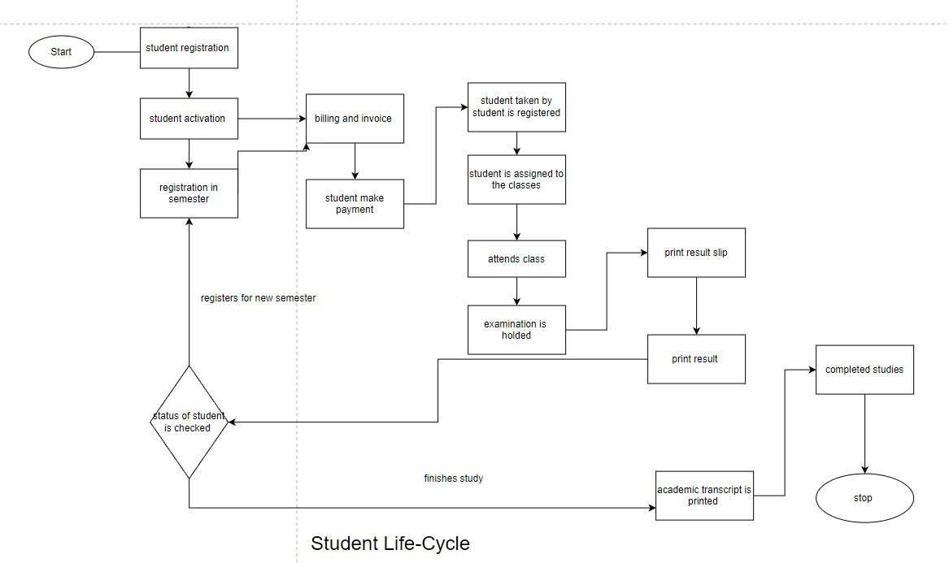

2.2.1.1.2 Personal Tutorial Life-Cycle

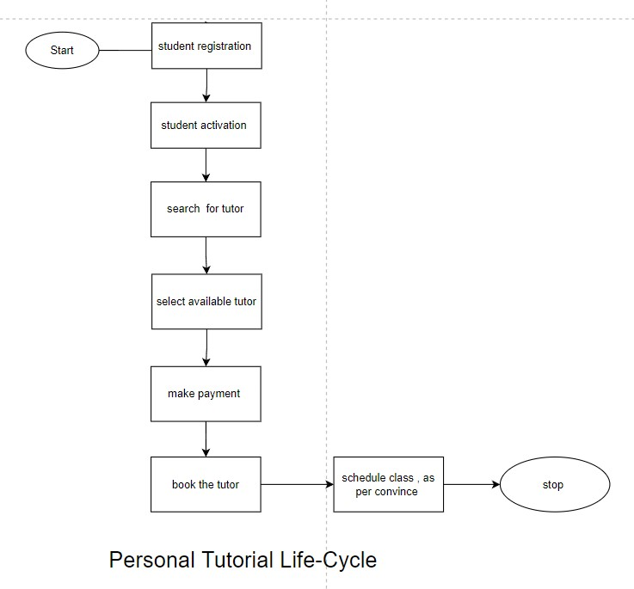

2.2.1.1.3 Optional Process 1

2.2.1.1.4 Optional Process 2

2.2.1.2 Summary of existing business limitations requiring resolution and existing strengths.

The Woodlands University is an existing business that operates on a paper-based system. This university also intends to offer a wide range of degree courses. The issues and problems that were identified during the interview are very serious and must be addressed, which is why the institution intends to develop software and a website, as well as transition from a paper-based to a computerized system.

The following are the most significant downside of current business:

* The university's student, employee, and instructor record management system is purely manual, which is time consuming and tiresome.
* Paper documents are less secure since they can easily be misplaced and fall into the wrong hands, with no way of recovering them.
* The document grows in parallel with the company's growth, resulting in a shortage of space since paperwork grows at the same rate.
* It's possible that students will bribe the teacher to skip the long line.
* There are no adequate methods of communication when events and curriculum activities occur in college.

2.2.2 Functional Requirements

A computation, data manipulation, business procedure, user interaction, or any other specialized capability might be required. Functional Specification is another term for functional requirements in software engineering. A Functional Requirement might be anything from a high-level abstract explanation of the sender's need to precise mathematical functional requirement specifications. The anticipated behavior of the system may be captured using functional software requirements. It refers to a piece of software or a component of one. A function is a collection of inputs, behavior, and outputs for a software system.

*Features required*

* Admin:

1. The system should handle the admission and registration of new students, including their personal information and data.
2. Only the administrator should be able to register new staff, students, and workers by entering their personal information.
3. The scholarships can only be assigned to students by the administrator.
4. Admin should be in charge of seeing and managing the college's financial transactions.
5. Admin should only be allowed to add new users by giving them a login/username and password.

* Tutor:

1. Personal information about employees should be preserved..
2. Staff and student attendance information should be preserved and represented by them.
3. The system should generate the payable salaries of the employees.
4. Teachers should be able to see details about their students as well as update and control their test grades.

* Students:

1. Automated attendance should be taken..
2. The student's personal details should be recorded in full.
3. Individual student grades should be shown on their own login page.
4. Students' fee information should be provided so that they may see how much money is owed to them and how much money they have already paid.

* Course:

1. When students enroll in the new system, they should have access to course details.
2. Every course should have its own name, and each tutor should be able to access their own course.

* Department:

1. The new system should display the department a student is in, how many of them there are, and when they started.

* Scholarship:

1. The new should provide a unique id for each student who has received a scholarship..
2. The details of the scholarship, including how much and when it was awarded, should be given and recorded by the system.

2.2.2.1.1 Records Management Systems

In the table below, the purpose of each relevant field has been presented in a distinct colour to illustrate the possible accessibility:

The course management system's recording activities is seen below:

|  |  |  |  |  |  |
| --- | --- | --- | --- | --- | --- |
| Operation | Super Admin | Admin | Module leader | Tutor | Student |
| Add | Add new student, tutor and staff  information to the data list | Add tutor and student | **No access** | **No access** | **No access** |
| Remove | Able to delete the list of student, tutor and staff the | Make a list of student and tutor | **No access** | **No access** | **No access** |
| Create | Create a new record. | Create a new record. | **No access** | **No access** | **No access** |
| Amend | Change and correct the record details | Change and correct the record details | **No access** | **No access** | **No access** |
| Archive | Move an unnecessary record to archive. | Move an unnecessary record to archive. | **No access** | **No access** | **No access** |
| Delete | Erase the data | Erase the data | **No access** | **No access** | **No access** |
| Display | Display all the list of information about student, tutor and staff | Display all the list of information | Display the list of student and tutor | Show Information about the personnel | Show their personal |
| Assign | Assign the information of newly added animals to the appropriate categories. | Assign the information of newly added animals to the appropriate categories. | **No access** | **No access** | **No access** |
| Attendance | Take a look and can maintain and keep of track of student staff and tutor | can maintain and keep of track of student staff and tutor | can maintain and keep of track of student and tutor | can maintain and keep of track of student | **No access** |
| Assignment | Keep track of given assignment | Keep track of given assignment | Able to update download and edit | Able to update download and edit | Able to see and download |
| Result | Add | Able to view and add | Able Insert | Able to view add and maintain rubric | Only Able to view marks |
| Dairy | Able to edit, create, change | Able to edit, create, change | Able to view ticket details | Manage the ticket sales system | The price of a ticket can be viewed and buy. |
| Search | Add necessary search for animals, events and correct them | Find the necessary animals and events and make the necessary corrections. | Able to search animals and events information | Able to find about the animals. | Search the zoo catalogue using a search engine. |

1. Admin

|  |  |  |  |
| --- | --- | --- | --- |
| Attributes | Type/format | Constraints | Notes |
| admin_id | NUMBER (8) | PK | Primary key for the manager. |
| admin_first_name | VARCHAR2(13) | UPPER | Admin first name. |
| admin_last_name | VARCHAR2(13) | UPPER | Admin Last name. |
| contact_number | NUMBER (30) | NOT_NULL | Admin Contact number. |
| house_number | VARCHAR2(5) | NOT_NULL | Admin House number. |
| City | VARCHAR2(10) | NOT_NULL | The city where the admin resides. |
| country | VARCHAR2(5) | NOT_NULL | The country in which the admin resides. |
| date_of_birth | DATE | NOT_NULL | Admins date of birth. |
|  |  |  |  |

1. Module leader

|  |  |  |  |
| --- | --- | --- | --- |
| Attributes | Type/format | Constraints | Notes |
| module_leader_id | NUMBER (12) | PK | Primary key for the module leader. |
| module_leader_first_name | VARCHAR2(40) | UPPER | module leader first name. |
| module_leader_last_name | VARCHAR2(40) | UPPER | module leader Last name. |
| module_leader_address | VARCHAR2(35) | UPPER | module leader address. |
| Town | VARCHAR2(10) | UPPER | The city where the module leader resides. |
| County | VARCHAR2(10) | UPPER | The country in which the module leader resides. |
| contact_number | NUMBER (45) | NOT_NULL | module leader Contact number. |
| Gender | CHAR | CHECK IN (‘M’, ‘F’), NOT_NULL | The module leader gender. |
| Email | VARCHAR2(40) | UNIQUE | module leader email address. |
| date_joined | DATE | NOT_NULL | The year the module leader became a member of the University. |

1. Tutor

|  |  |  |  |
| --- | --- | --- | --- |
| Attributes | Type/Format | Constraint | Notes |
| tutor_id | Number (10) | PK | Primary key for the tutor. |
| tutor_full_name | VARCHAR2(15) | UPPER | tutor full name. |
| tutor_address | VARCHAR2(20) | UPPER | Tutor address. |
| Email | VARCHAR(10) | UNIQUE | Tutor email address |
| tutor_role | VARCHAR(5) | NOT_NULL | The subject that tutor teaches. |

1. Student

|  |  |  |  |
| --- | --- | --- | --- |
| Attributes | Type/format | Constraints | Notes |
| student_id | NUMBER (10) | PK | Primary key for the student. |
| student_first_name | VARCHAR2(30) | UPPER | Student first name. |
| student_last_name | VARCHAR2(30) | UPPER | Student Last name. |
| student_address | VARCHAR2(40) | UPPER | Student address. |
| Town | VARCHAR2(20) | UPPER | The city where the student resides. |
| County | VARCHAR2(20) | UPPER | The country in which the Student resides. |
| contact_number | NUMBER (25) | NOT_NULL | Student Contact number. |
| Gender | CHAR | CHECK IN (‘M’ , ‘F’) , NOT_NULL | The Student gender. |
| Email | VARCHAR2(30) | UNIQUE | Student email address. |
| date_joined | DATE | NOT_NULL | The year the student enrolled in University. |

2.1.3.1.2 Student Records/Information Portal

|  |  |  |  |
| --- | --- | --- | --- |
| **Attributes** | **Description** | **Type** | **Format** |
| student_ID (PK) | Student ID Number | Int | 11 |
| Student_fname | Student First Name | Varchar | 30 |
| Student_lname | Student Last Name | Varchar | 30 |
| Student_course | Student Course | Varchar | 30 |
| Student_year | Student Year | Int | 11 |
| Student_contact | Student Contact Number | Int | 11 |
| Student_age | Student Age | Int | 11 |
| Sudent_birthdate | Student Birth Date | Date |  |
| Student_gender | Student Gender | Int | 11 |

2.1.3.1.3 Woodlands University College Corporate Website

|  |  |
| --- | --- |
| **Requirements** | **Description** |
| Home page | This page will include a crucial introduction, details, information, university values, and the website's goal. |
| Contact page | This page will include contact information, allowing employees, students, and other interested parties to communicate with the appropriate persons in the appropriate departments. |
| About us | This page will feature the university's information, descriptions, departments, and history. |
| Gallery page | This page contains images and visual information about the institution so that interested parties, staff, and students may learn more about the university's academic environment. |
| Courses | This page provides a comprehensive summary of all of the university's courses and teachers. |
| Events | This website provides historical photographs and visual information from numerous festive events hosted at the institution, as well as information on forthcoming or ongoing events. |
| News | This website contains up-to-date information on the university, its activities, and its students, as well as local and worldwide information relevant to the students or their academic education. |
| Apply | This page allows interested individuals and future students to apply to the university and register for any of the institution's courses and modules. |
| Login | This is the webpage or entry page to the university website that needs user identification and authentication, which is often supplied by the institution to its students and employees in order to keep them informed and provide private information. |